KENDRIYA VIDYALAYA SANGATHAN, RAIPUR REGION
MARKING SCHEME
SAMPLE PAPER (SESSION 2023-24)
Class: XII Subject: Chemistry
MM:70 Time:3:00 Hours
 | SECTION A(1 MARK)
1 | (c) Pentaacetate of glucose does not react with hydroxylamine. | 1
2 | (b) gem-dihalide | 1
3 | (c) Salicylic acid | 1
4 | (c) [CO (H₂O)₆]³⁺ > [CO(NH₃)₆]³⁺ > [CO(CN)₆]^{3–} | 1
5 | (a) Butane < 1-Chlorobutane < 1-Bromobutane < 1-Iodobutane | 1
6 | (a) adenine and thymine ; guanine and cytosine | 1
7 | (d) Prop-1-en-2-ol, tautomerism | 1
8 | (b) 3.87 B.M. | 1
9 | (a) Activation energy of forward reaction is E1 + E2 and product is less stable than reactant. | 1
10 | (b) 251.5 | 1
11 | (d) iii > i > ii > iv | 1
12 | (a) C₆H₅SO₂Cl | 1
13 | (d) A is false but R is true | 1
14 | b) Both A and R are true but R is not the correct explanation of A. | 1
15 | (c) A is true but R is false. | 1
16 | (d) A is false but R is true | 1
 | SECTION-B(2 MARKS)
17 | 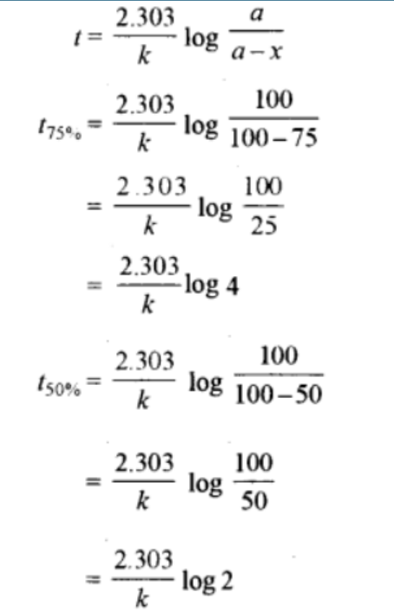  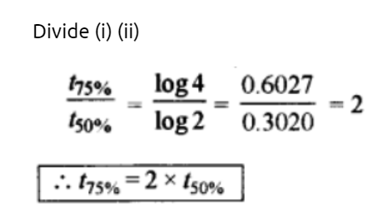 | 1  1
18 | (a) PCC(pyridinium chlorochromate)  (b) 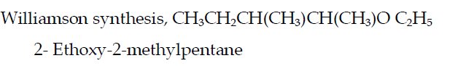  OR  - (i) 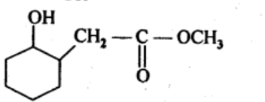(ii) 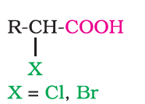  - Propan-2-ol (2*) alcohol takes 5 minutes to give turbidity with lucas reagent(HCl/ZnCl2) wherease propan-1-ol(1*) does not give test  CH₃CH(OH)CH₃ + HCl/ZnCl2-→CH3CH(Cl)CH3 (five minutes) | ½  ½  ½  ½  OR  ½  ½  1
19 | - Amino acids have amino (−NH2) group, basic in nature and accepts a proton and COOH group loses a proton forming a dipolar ion, called the Zwitter ion. In this form, amino acids behave both as acids and bases so they are amphoteric in nature  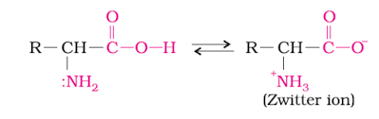  (b)Vitamin that can be synthesized ‘.Vitamin B12  Disease due to the deficiency of Vitamin B12: Pernicious anemia. | 1  ½  ½
20 | (a)  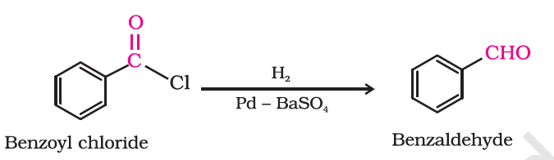  (b)  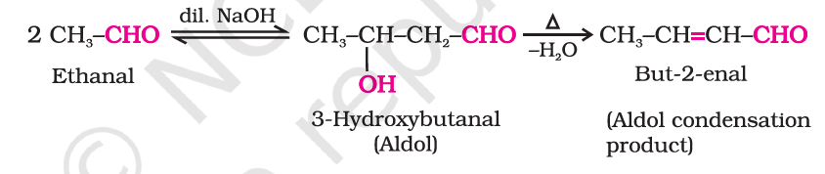 | 1  1
21 | - Hexaaquanickel(II) chloride  (b)  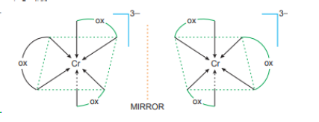 | 1  1
 | SECTION-C (3 Marks )
22 | 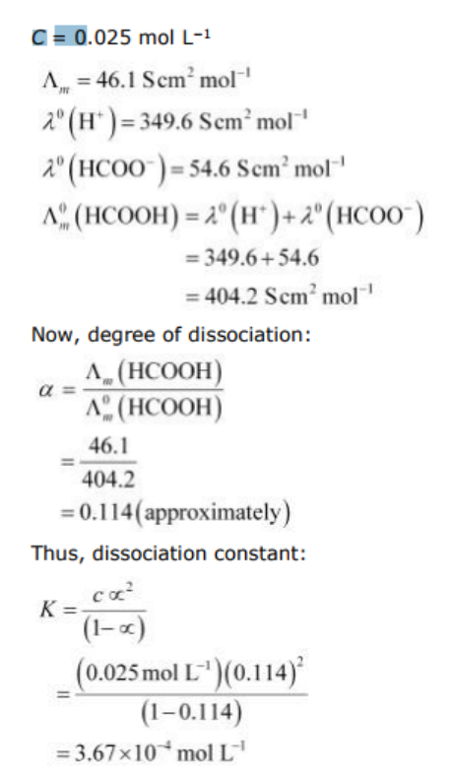 | ½  1  ½  1
23 | Compound A is 2-methylbut-2-ene, B-Ethanal C-Propan-2-one  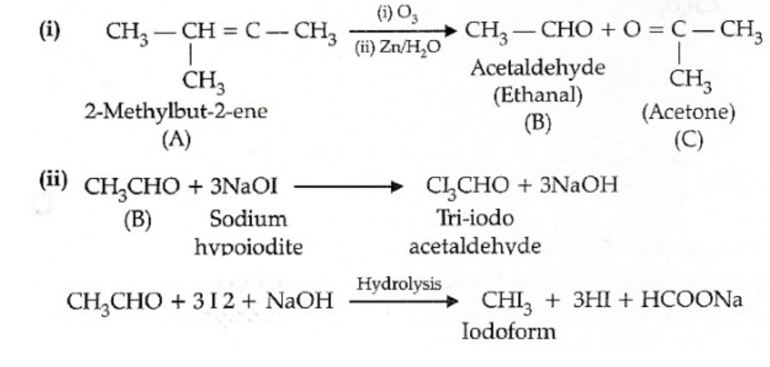 | 1  1  1
24 | 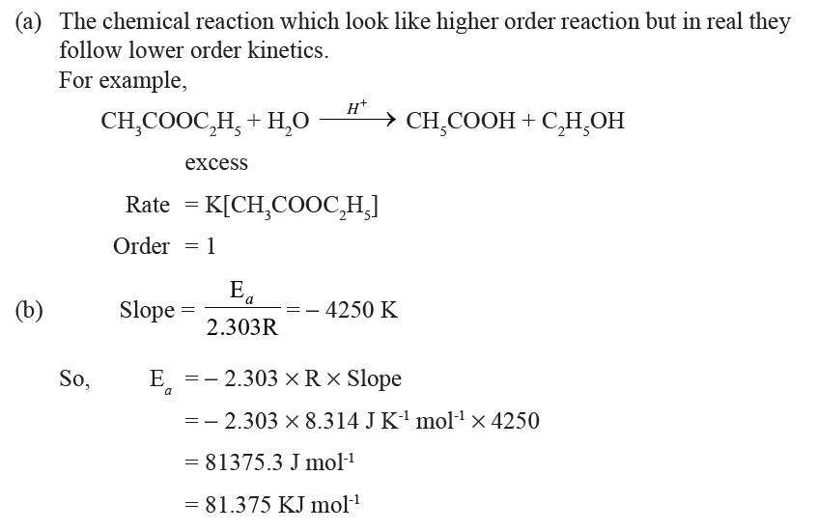 | ½  1  ½  ½  ½
25 | - When an egg is boiled, the proteins present inside the egg get denatured and coagulate. After boiling the egg, the water present in it is absorbed by the coagulated protein through H-bonding  (b)  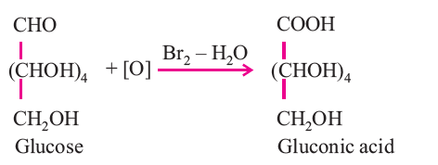  (c) Amylose : A linear polymer of α-glucose, water soluble.  Amylopectin : Branched polymer of α-glucose, water insoluble. | 1  1  ½  ½
26 | (a)  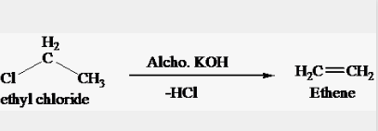  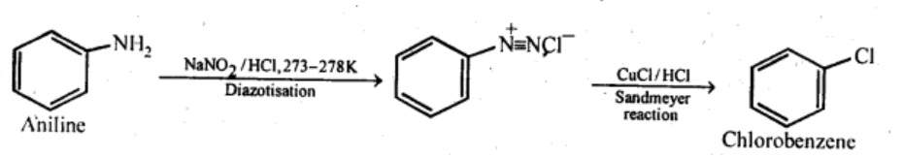  (c)  (d)  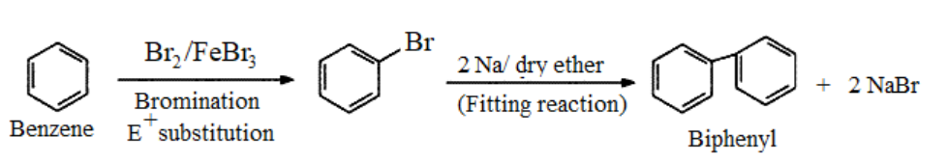  (Any three) | 1  1  1
27 | 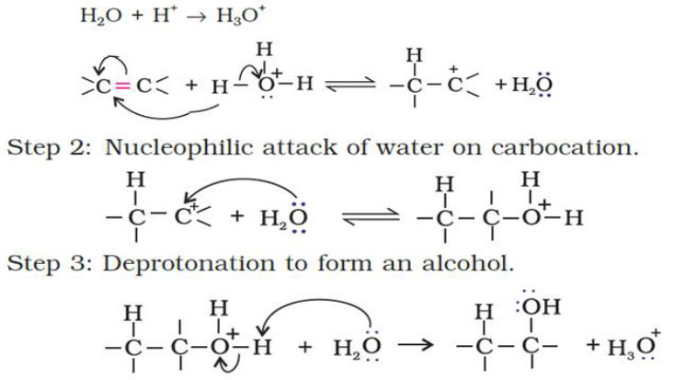 | 1  1  1
28 | - Helium ,as greater the K_{H} value lower the solubility.  - Because the magnitude of osmotic pressure is large even for very dilute solution and it can be measured at room temperature  - Salt decreases the freezing point of water. As a result, the snow starts melting from the  surface and therefore, it helps in clearing the roads. | 1  1  1
29 | - In the complex [Ti(H₂O)₆]³⁺, the Ti atom has oxidation state of +3. Its outer electronic configuration is 3d¹. It has one unpaired electron. This unpaired electron is excited from t2g level to eg level by absorbing blue-green light and hence appears violet coloured.  - t₂g³, eg¹  (c) In [Co(NH₃)₆]³⁺, the d-electrons of Co³⁺ ([Ar]3d₆ 4s°) get paired leaving behind two  empty d- orbital and undergo d2sp3 hybridization and hence inner orbital complex, while in  [Ni(NH₃)₆]²⁺ the d-electrons of Ni²⁺ ([Ar]3d⁸ 4s°) do not pair up and use outer 4d subshell  hence outer orbital complex.  OR  - The presence of CO ligand, which is a strong ligand, can pair all electrons in Ni(CO)4 and thus it is diamagnetic in nature but Cl− is a weak ligand and is unable to pair up the unpaired electrons and thus [NiCl4]2− is paramagnetic in nature | 1  1  1+1
30 | - Maximum boiling azeotropes.  - ‘B’ will have lower vapour pressure because its boiling point is higher.  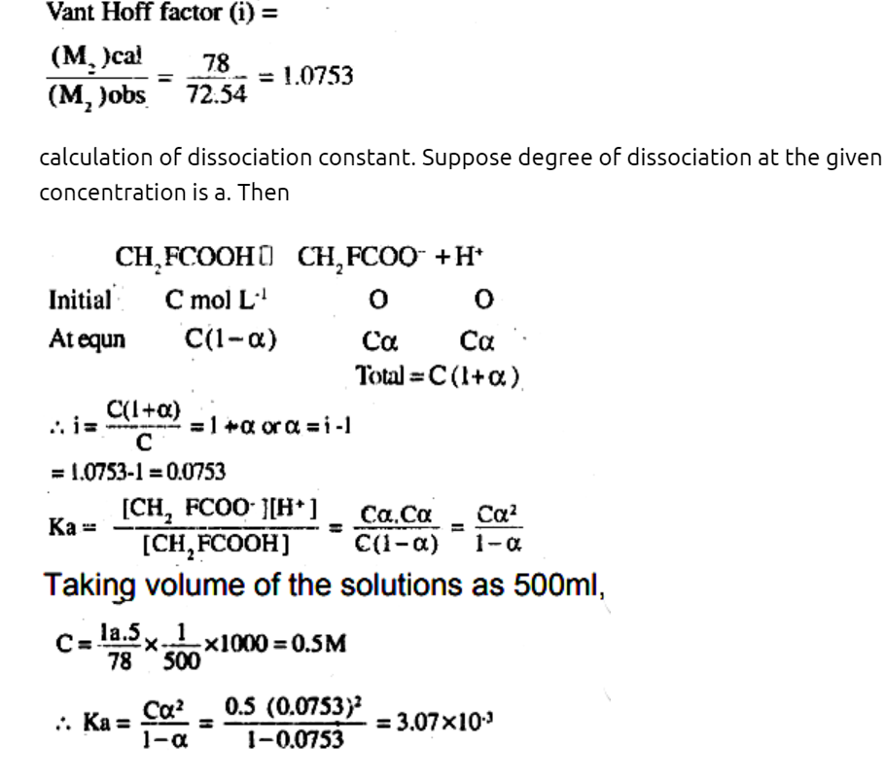  OR  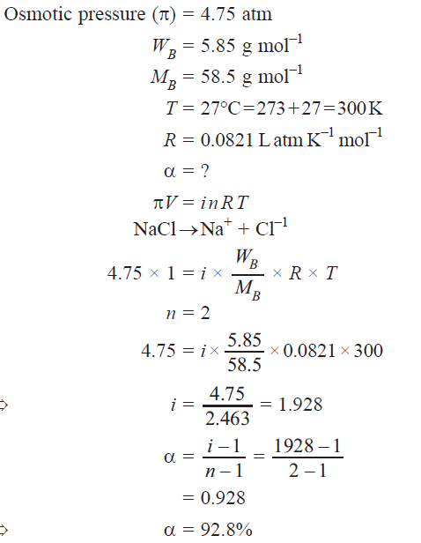 | 1  1  2
31 | - This is due to the increasing stability of the lower species to which they are reduced.  Cr²⁺ is strongly reducing in nature. It has a d4 configuration. While acting as a reducing agent, it gets oxidised to Cr³⁺ . This d³ configuration can be written as t₂3 configuration, which is a more stable configuration. In the case of Mn³⁺ (d⁴) to Mn²⁺ (d⁵). This has an exactly half filled d - orbital and is highly stable.  - The lower oxide of transition metal is basic because the metal atom has low oxidation state and still has electrons to donate whereas highest is acidic due to highest oxidation state and not left with free electrons  - it undergoes change in oxidation state from +2 to +3 and is easily oxidised. This is because C_{O}³⁺ has more tendency to form coordination complexes than Co²⁺  - Because hydrochloric acid is oxidised to chlorine (Cl₂)  - The ions in d configuration tend to lose one more electrons to get into stable d⁰ configuration. Also, the hydration or lattice energy is more than sufficient to remove the only electron present in the d-orbital of these ions. Therefore, they act as reducing agents.  - they are capable of exhibiting different oxidation states and hence they act as both oxidizing and reducing agents at the same time.  - Transition metals have very similar atomic sizes. One metal can easily replace the other metal from its lattice to form solid solution (alloy). Transition metals are miscible with one another in the molten state. (any 5) | 1  1  1  1  1
32 | - (i) because the lone pair on the nitrogen atom is in conjugation with the carbonyl group in acetylated aniline  (ii) due to salt formation with aluminium chloride which is used as a Lewis acid catalyst. Positive charge on nitrogen is strongly electron-withdrawing and thus deactivates the ring for further acylation or alkylation reactions.  - 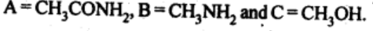  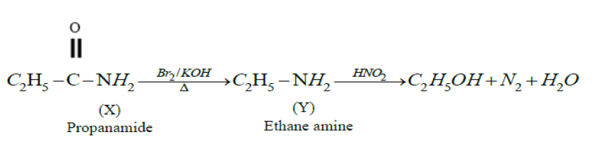  OR  - Methyl amines gives offensive smelling compound. (Methyl isocyanide) on treatment with CHCl₃ & KOH while dimethyl amine does not react.  - C₆H₅NH₂> C₆H₅NHCH₃>C₂H₅NH₂> (C₂H₅)₂NH  - (i) CH3COOH^{NH3}→ CH3CONH2 Br2+KOH→ CH3NH2  ^{(ii)} 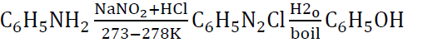  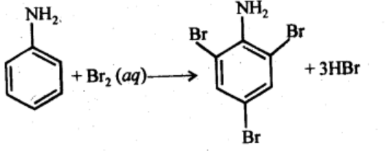 | 1  1  ½  ½  ½  ½  ½  ½  OR  1  1  1  1  1
33 | (a) Yes, if the concentration of ZnSO4 in the two half cell is different , the electrode potential will be different making the cell possible.  (b)  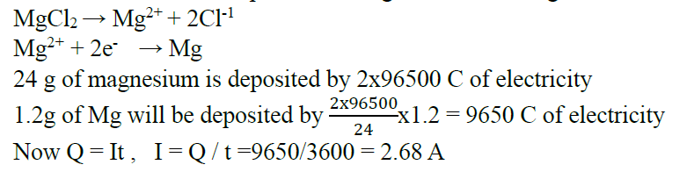  (c)  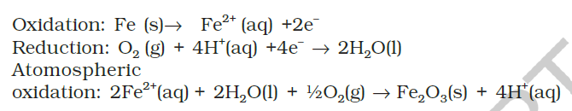  Alkaline medium prevent the availability of H+ ions.This reduces the rate of oxidation of Fe to Fe^{2+.}.  OR  a) CH₃COOH is a weak electrolyte. With dilution, its degree of dissociation increases i.e. more ions are released in solution. On the other hand, CH₃COONa is a strong electrolyte. With dilution, only interionic forces of attraction increase resulting in only small increase in the value of Λ_{m}  b)  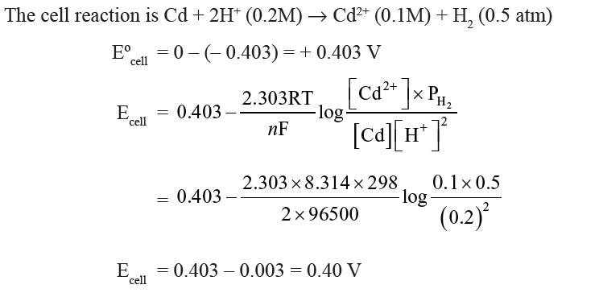  (c)  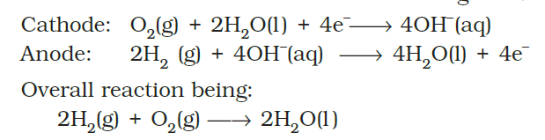  Primary batteries or cells contain a limited amount of reactants and are discharged when the reactants are consumed. Secondary batteries or cells can be recharged but the process takes a long time. Fuel cells work continuously as long the reactants (i.e. fuel) are supplied. | 1  1  1  1  1  OR  1  1  1  1  1

